***Image recognition of Cars and motorbikes***

***Makeing and Model Using Convolutional Neural Networks , KNN and SVM***

***Abstract***

**V**ehicle detection and identification is an important task in the area of traffic control and management. Typically, to tackle this task, large datasets and domain-specific features are used to best fit the data. In our project,

with the added constraint of limited data and time. We report and compare these results to that of baseline models, and discuss the advantages of this approach.

1. **Introduction**

Generally speaking, This classification can be very challenging due to more subtle differences between classes, compared to basic recognition, such as on ImageNet. Recognizing the makes and models for Vehicle (Cars or motorbikes) is one such task. For humans, this is usually a fairly straightforward task, especially for Vehicle. Vehicle can usually be identified by **human** eye due to certain key aspects, such has logos, hood ornaments, or lettering. However, due to the visual complexity of Vehicle ,

this has traditionally been a hard task for **computers**. The main challenge for fine-grained classification is unarguably the very fine differences between different classes. Typically, to learn these minute differences, a dataset is needed. However, in a setting with limited time, computational power, or data

We conducted experiments on Vehicles dataset, a fine-grained dataset containing 2 different classes of Vehicle (Cars and motorbikes). This dataset is particularly challenging due to the freeform nature of the images, which contained Vehicle in many different sizes , colors and shapes. Despite our resource limitations and the difficulty of the task, we were able to obtain high quality results from fine-tuning.

**2. Previous Work**

2.1. CNNS In recent years, much work on image processing and classification has been done with convolutional neural networks (CNNs). The power of CNNs is their capacity for learning not only the weights of features, but the features themselves as well. Recently, these CNNs have achieved state of the art accuracy on generic image classification . In this project, we make extensive usage of CNNs as our primary architecture of classifiers.

**3. Approach and Algorithms**

To alleviate the data and time constraints imposed on us, we chose and used Tensorflow, scikit learn and Keras deep learning frameworks , to construct, train, and test our networks. The following subsections describe the models used in this project.

**3.1. Baselines**

We implemented two simple baselines: an SVM and 3-Hidden layers and 1 output CNN. Our =>baseline SVM setup consists of a single fully connected layer with softmax loss.

=>Simple conv-net setup. Our baseline convolutional neural network consists of a ReLU set, followed by a fully-connected layer with softmax loss. This baseline provides a reference for the performance of a simple CNN approach.

**4.1. Source**

We exclusively used 2 datasets provided by

cars :

<https://ai.stanford.edu/~jkrause/cars/car_dataset.html>

motorbikes :

[http://www.vision.caltech.edu/html-files/archive.html](https://l.facebook.com/l.php?u=http%3A%2F%2Fwww.vision.caltech.edu%2Fhtml-files%2Farchive.html&h=ATOnEvm7UhoeHL6TAKdNjOsC1lgvxUmZLzHPfX6n4gf_ZpjsMi1OTiTBQBci5-1Tasq06cMGYdVIOxztl3cMtOnW7bFBNO9We2BiD-G5RLCx4_osmcZxWQ)

This dataset contains 1706 image-classification pairs of 2 different classes, split into 1365 training and 341 test images. Each of the 2 classes is very different on the Shape of the vehicle.

Figure 1: A sample of images from the Vehicle datasets.

Each image consists of a car or motorbike in the foreground against various backgrounds and viewed from side angle. The quality of each image, as described by characteristics like the focal length, and positioning of the vehicle some images are professionally-taken press shots; others are relatively low-quality images collected from classifieds ads and other places on the internet.

**4.1. experiments**

CNN training

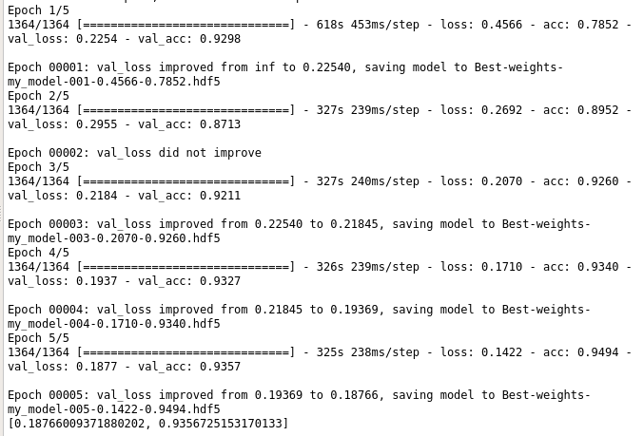

CNN testing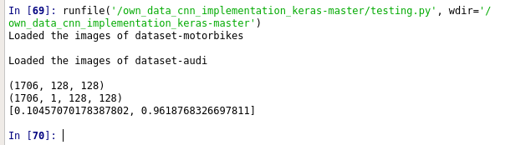

CNN training graphs for (accuracy and loss)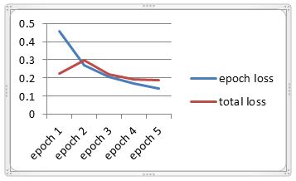

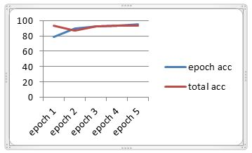

KNN while training accuracy

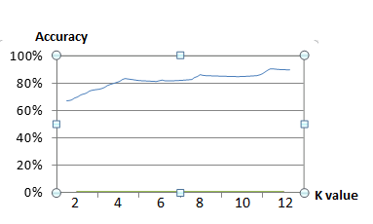

KNN training

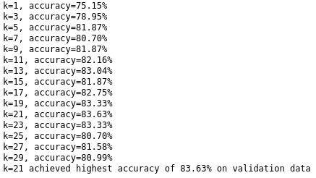

SVM accuracy

